METAGOL SPEC - Lobby

# Overview

* The lobby is a 3D space like a junction available to all players.
* From here the players can go ahead and travel to their desired destinations within the game.
* Here, players can find and interact with other players.

# Lobby

* For new players, after character creation, they are taken to the lobby.
* Here the player is shown all the movement and control schemes and FTUE.

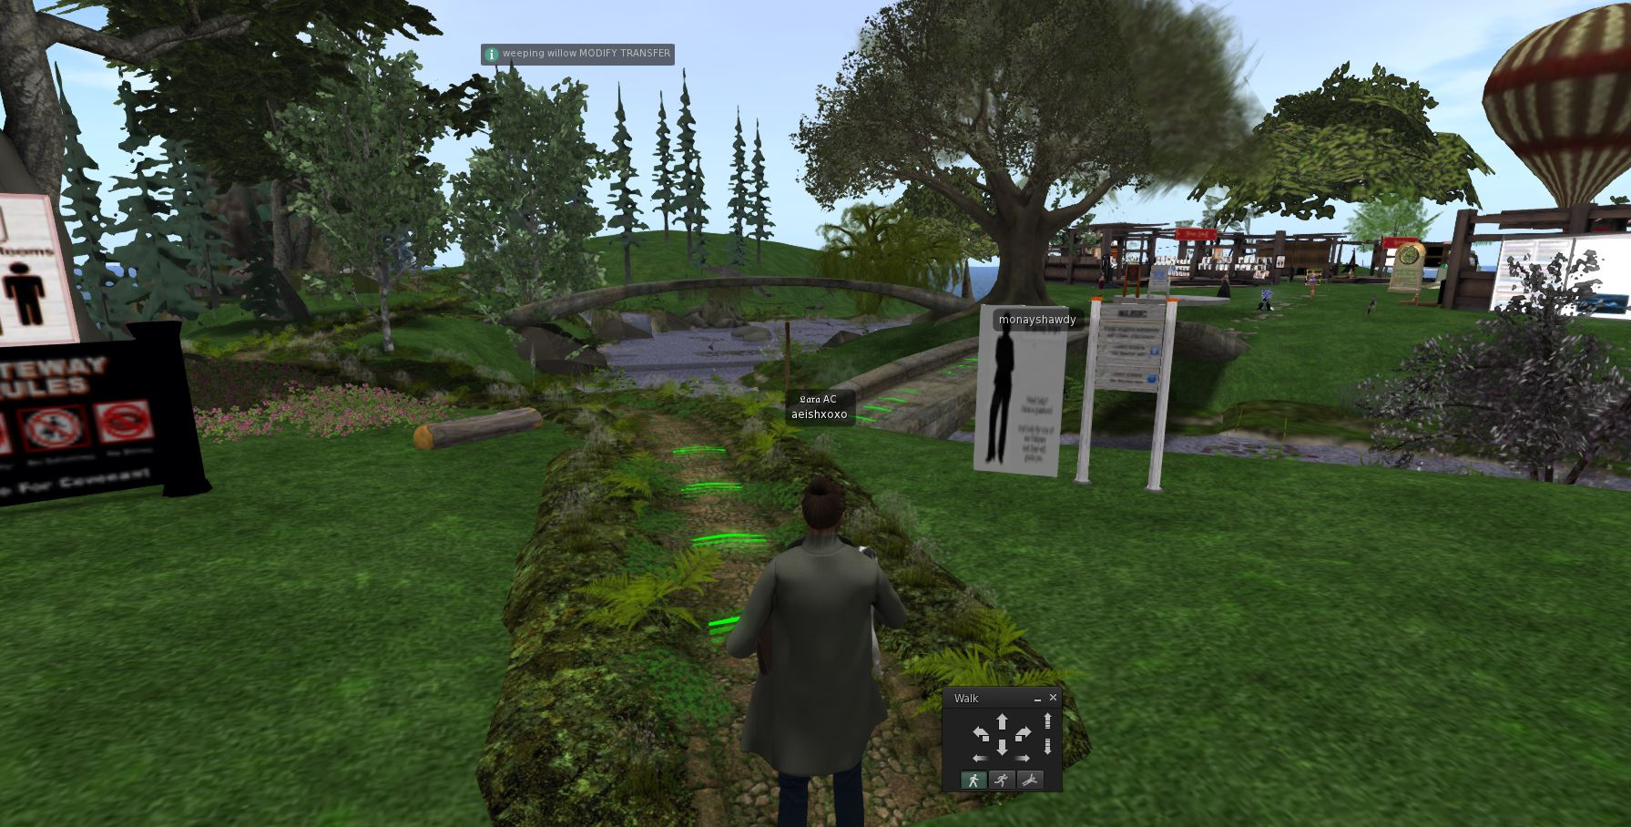

* The player is led to a junction of sorts through the FTUE.

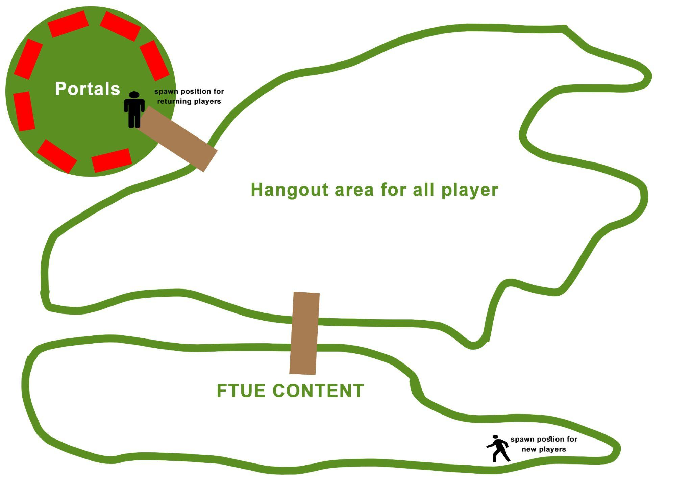

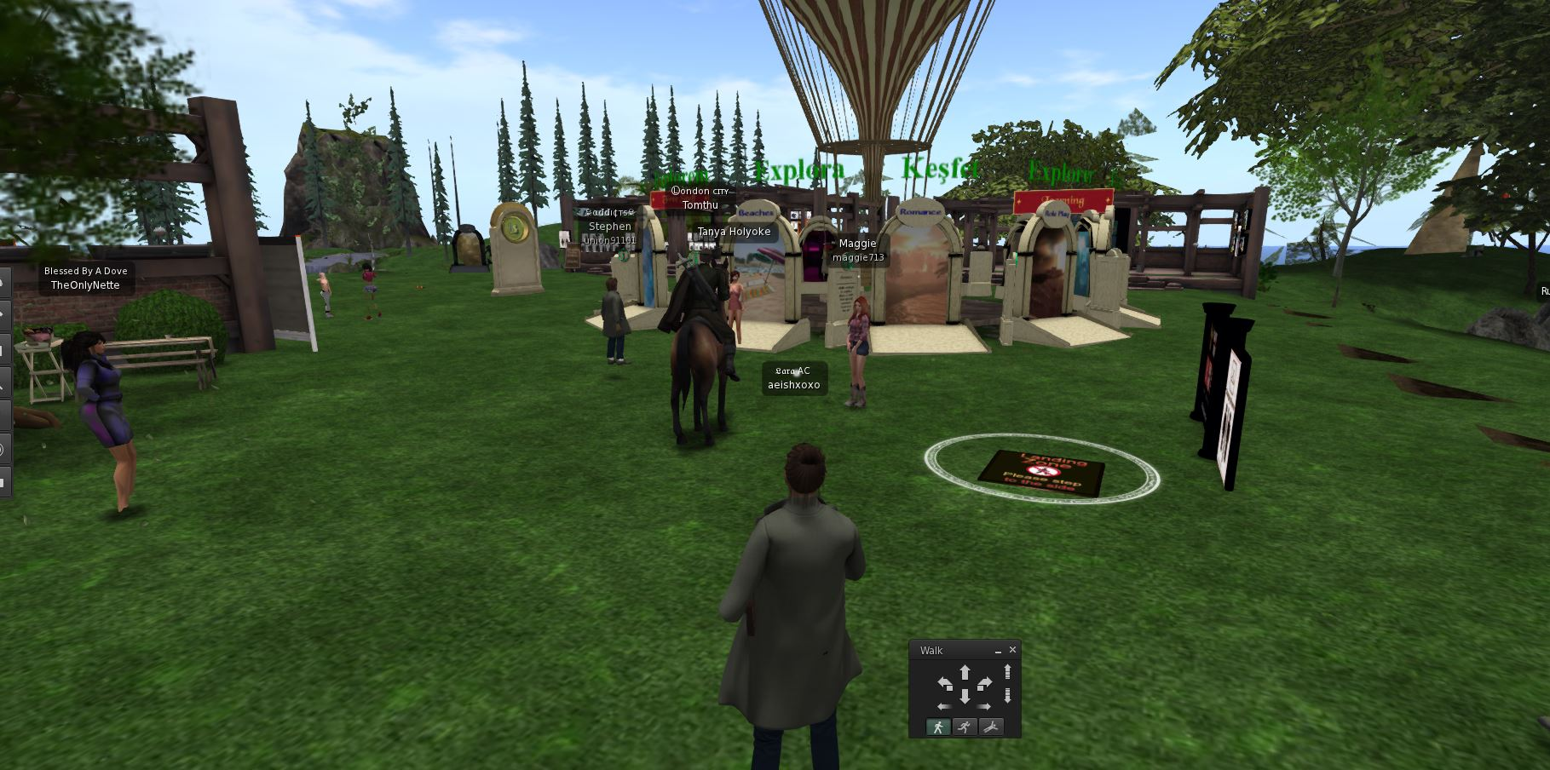

* Here the player can use portal like doors to :
  + the player can login to their own farm.
  + The player can visit friends’ farms and dedicated chat rooms.
  + Visit marketplaces, forests, etc.

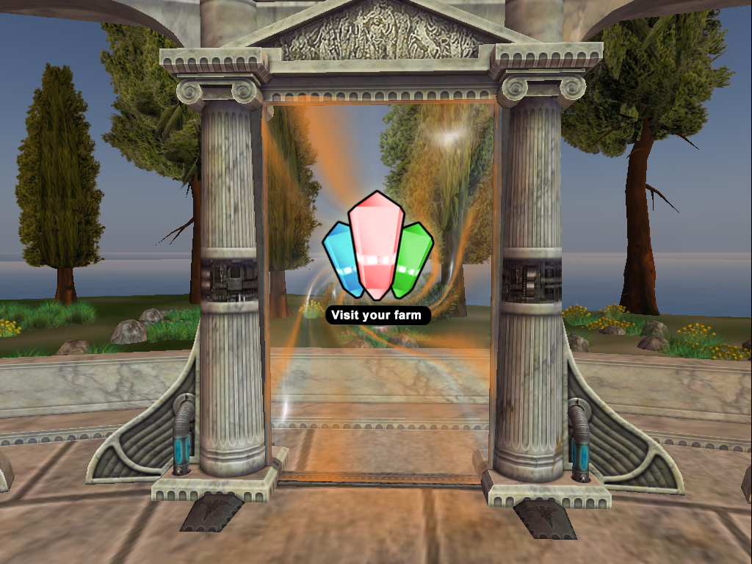

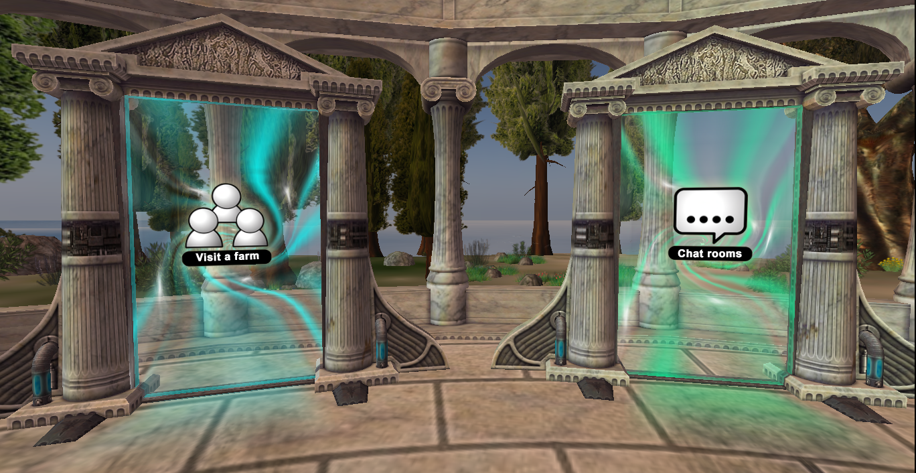

* The players can interact with other players and view their profiles using right mouse button. They can send friend requests and personal messages.

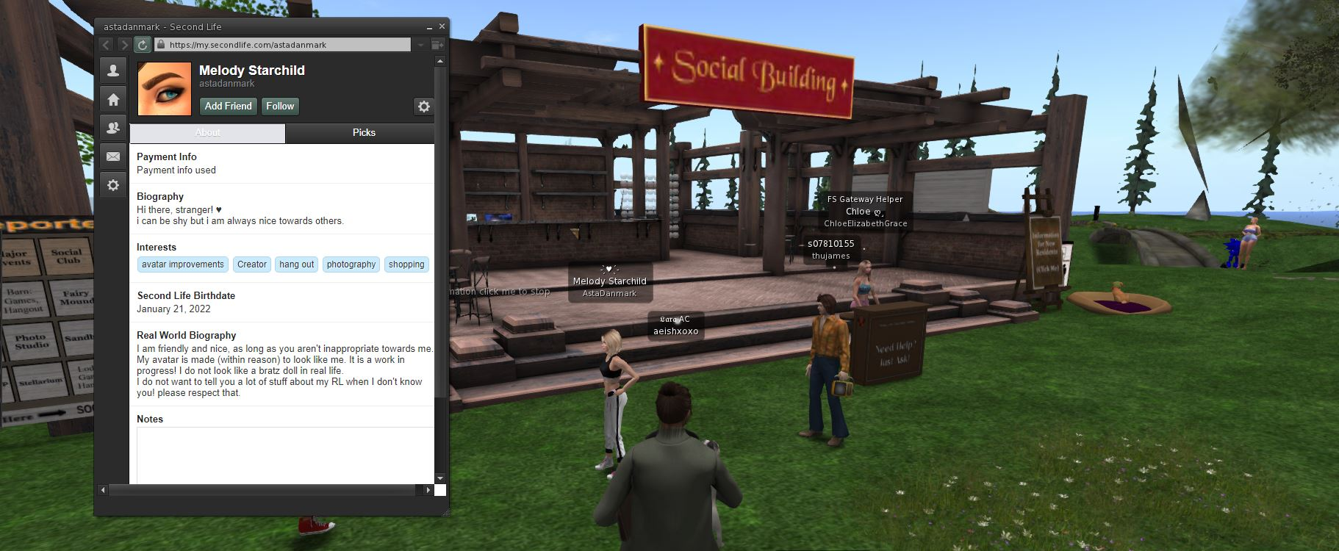

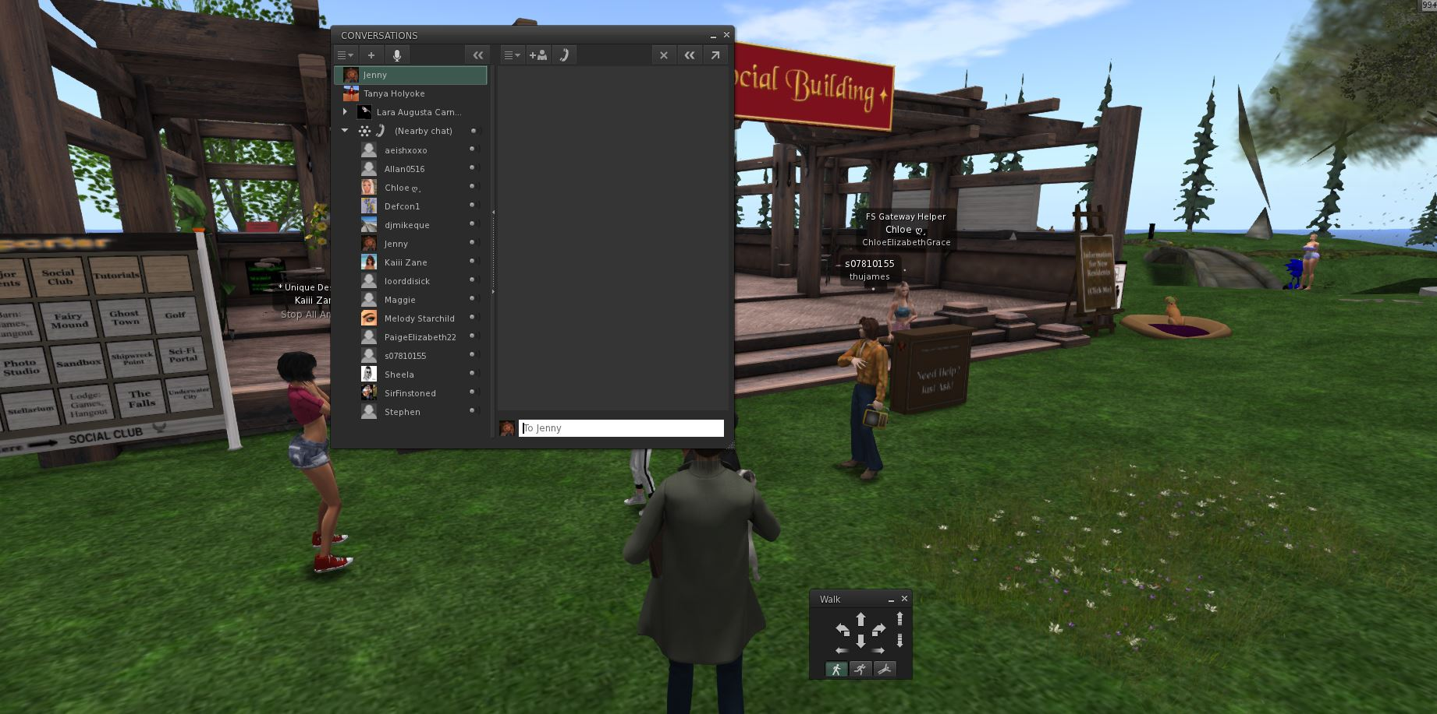

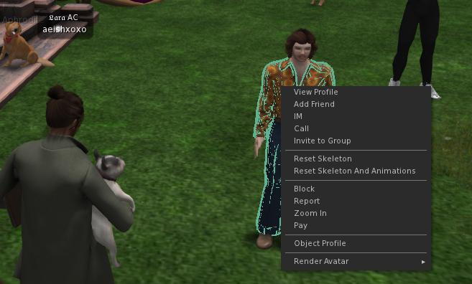

* The player can also connect their facebook accounts and send game invites to their facebook friends.